Aberdeen East – The Landings.
Front Door Policy.

Why this Policy?
This policy is a response to enquiries and requests to the ARC to replace a front door with a design that offers more than a like-for-like replacement, with the preference to incorporate more glazing. This is considered desirable to add more light into the living room and to create better safety conditions.
Meeting the Code.
A new door can open either outwards (incorporating a screen will be difficult if the door opens outwards) or inwards as is the existing arrangement. However, in order to meet the Code, the construction of an inward opening door must qualify for a Notice of Approval certificate from the City.
Policy.
1) An ARC shall be submitted to replace the front door. The design shall be selected from any of the patterns shown below.
2) The home-owner can select glazing patterns of his/her choice which can include a colored leaded design. The selected pattern must be a part of the ARC application.
3) The door frame and the solid part of the door construction must be painted the color of the existing doors, in accordance with the appropriate Landings policy, no other color will be permitted.
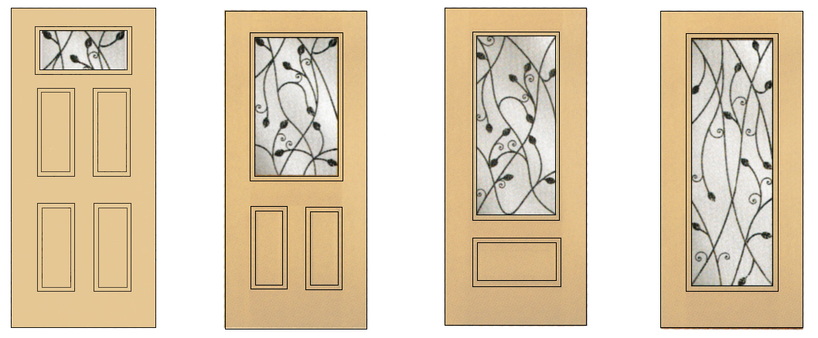
The Landings Board - February 2020. Website: www.landings-in-aberdeen.com

